HOW OIL SPILL EATER II (OSEII) WORKS
OSEII is a plant/bacteria based enzyme that breaks down any hydrocarbon into a natural food source for the native bacteria in the natural environment. The end result of the native bacteria degradation process is CO2 and water. OSEII is not a bacteria, fertilizer or dispersant.

OSEII BENEFITS & PROPERTIES
OSEII is non-toxic to humans, animals, plants and marine life. Non-poisonous, non-irritating. Contains no known allergens (skin or respiratory).
OSEII is 100% biodegradable. Has a 5-year + shelf life in concentrate form when stored at temperatures below 120-degrees.
OSEII suppresses vapors and malodors by destroying/degrading the source – does not mask the odor.
OSEII reduces fire hazard associated with volatile hydrocarbons (fuels)
OSEII eliminates the need for disposal. No skimmers or vac-truck required; works great on soil, pavement, gravel, docks, driftwood, mangroves, boats, shorelines, etc..

SIMPLE SCIENCE
OSEII is a bio-enzymatic cleaner that facilitates the tandem benefit of bacteria and enzymes working together. Crude Oil naturally exists on the planet, it is a petroleum hydrocarbon and is the parent to most refined petroleum hydrocarbons (fuels and oils) found in daily use and the environment. Hydrocarbon degrading bacteria also naturally exist in the environment. OSEII brings together native hydrocarbon degrading bacteria which exist everywhere in the environment, utilizes their own enzymes to breakdown the hydrocarbon molecule and turning it into a “food” making it fast and easy for the bacteria to biodegrade the petroleum hydrocarbon chemicals to CO2 and water. As long as the surface where applied remains sufficiently damp, the bacteria multiply and continue to remove traces of hydrocarbon for hours, days and even weeks after application.
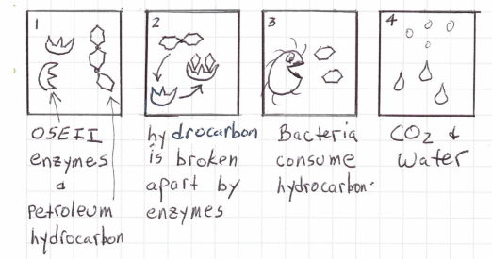
DETAILED SCIENCE
The OSEII enzymes are processed to form a nano-scale sized particle called a micelle. Micelles are a collection of linear molecules of fatty esters and fatty acids clumped together in the shape of a sphere 1-4 nanometers in diameter. The micelle’s small diameter combined with it’s extremely high surface area to volume ratio enable it to penetrate complex carbon molecules, like petroleum hydrocarbons, and emulsify organic matter. These linear molecules or micelles have a hydrophobic tail and a hydrophilic head and are activated when mixed with water so that each micelle is then completely surrounded by a thin layer of water molecules. The outer hydrophilic shell aggressively searches for and bonds with water molecules, making them hyper-mobile.
The colloidal micelles then work to break down long chain petroleum hydrocarbon bonds in fats, fuels, oils, and grease and holds them in suspension when mixed with water. Individual micelles repel each other like opposing magnets while attracting solid particles and breaking down hydrocarbon bonds into smaller molecules and/or atoms.
Once solid particles have attached themselves to the colloidal micelle, the micelle holds them in suspension, preventing re-attachment from occurring and safely allowing the fats, fuels, oils and grease to be permanently dissolved in water. The wash off is completely biodegraded and becomes compounds such as nitrate, dissolved oxygen, carbon dioxide, biomass, and water.

